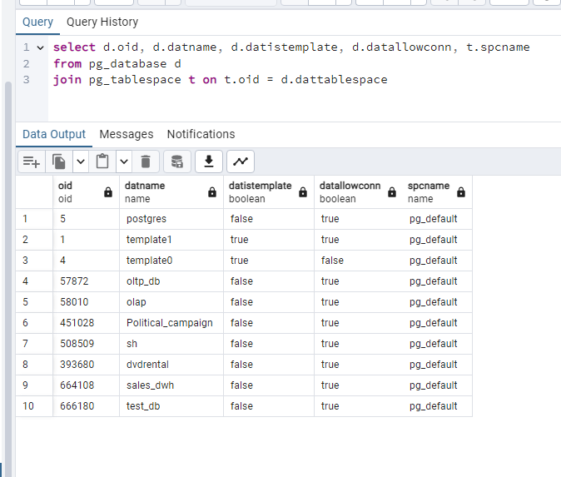

The query showed my databases and two templates.

I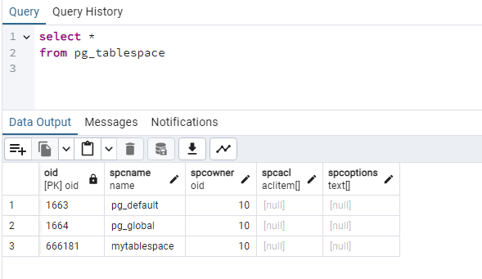 was able 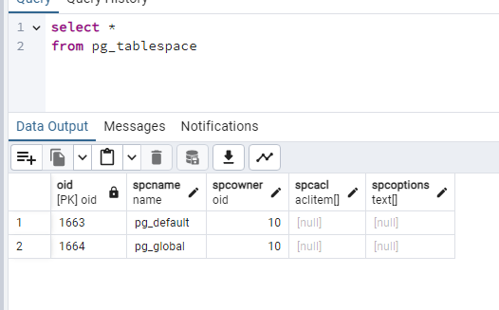to add a new tablespace.

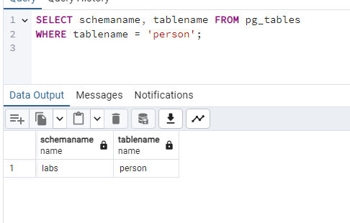

The schema and the table exist.

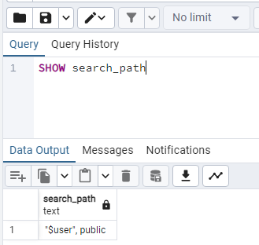

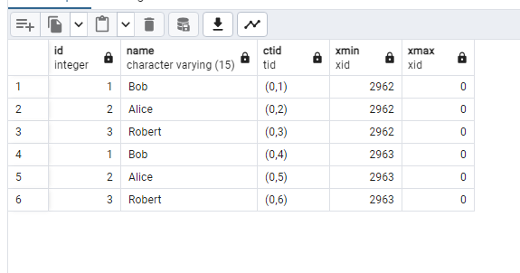

ctid shows the physical location of the tuple.

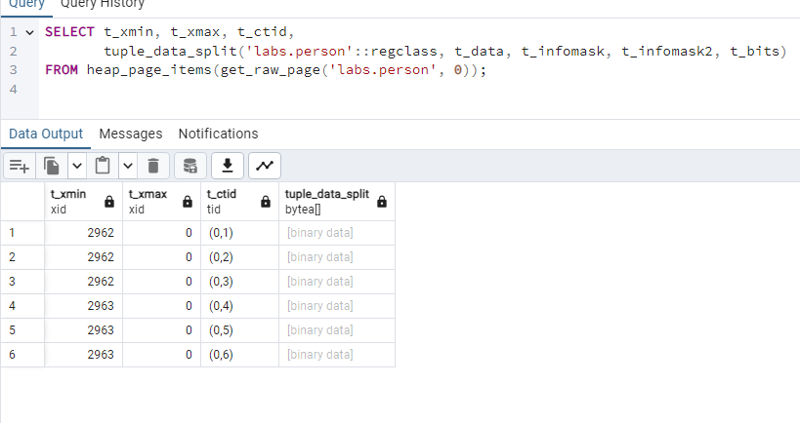After the inserts, it’s binary data everywhere.

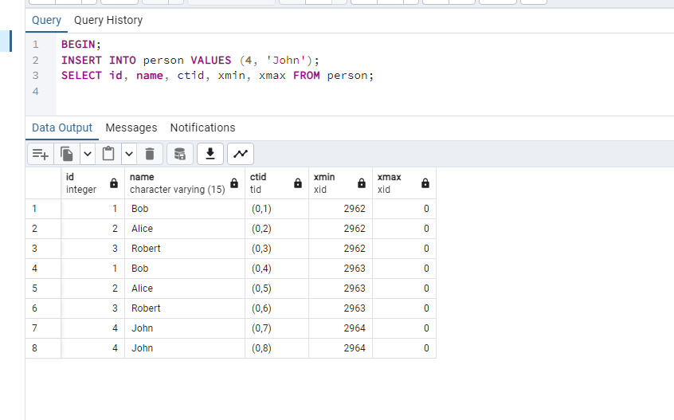John is added inside the transaction. (twice accidentally)

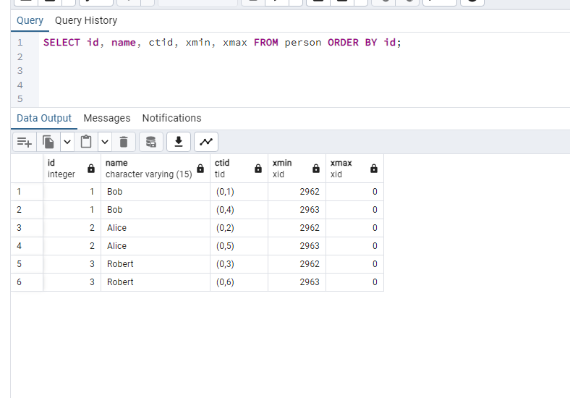Another session doesn’t see John until the transaction is commited.

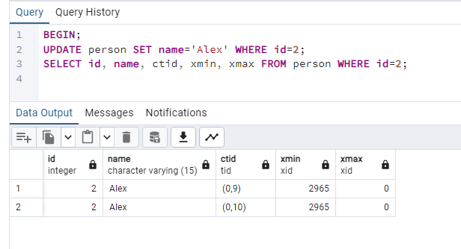

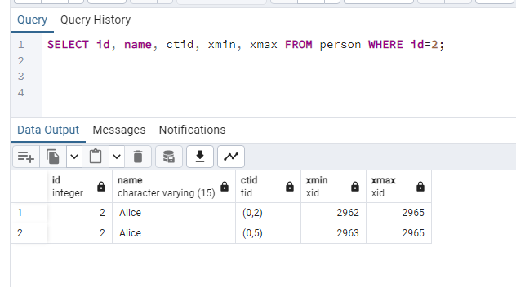

Update creates new tuple version, old tuple gets xmax set.

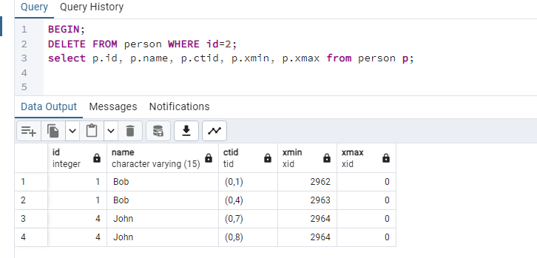

On delete the second session shows that xmax was set to the id of the transaction that did the delete operation.

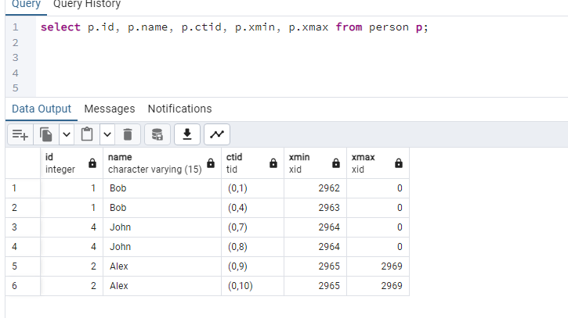

----------------------------------------------------------------------------

before vacuuming:

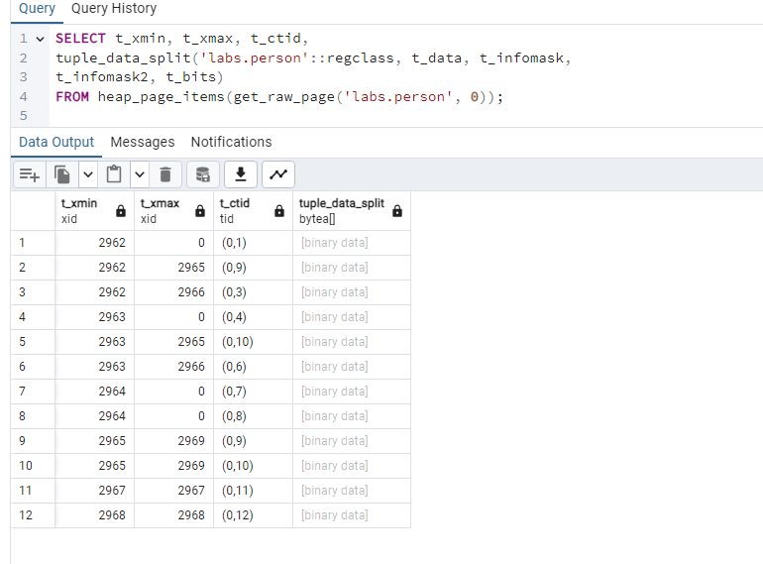

after vacuum labs.person:

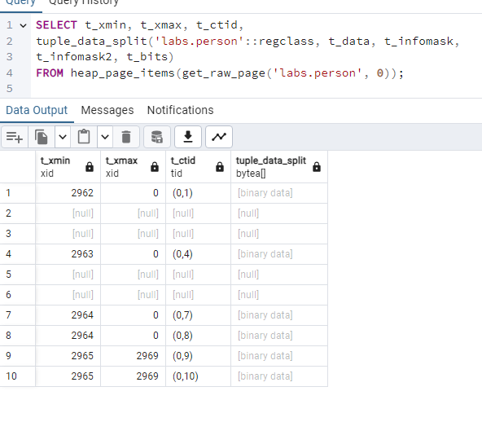

VACUUM does logical cleanup, it doesn’t clean the data on the disc. It preserves MVCC history while making space reusable.

-------------------------

After inserting Sarah:

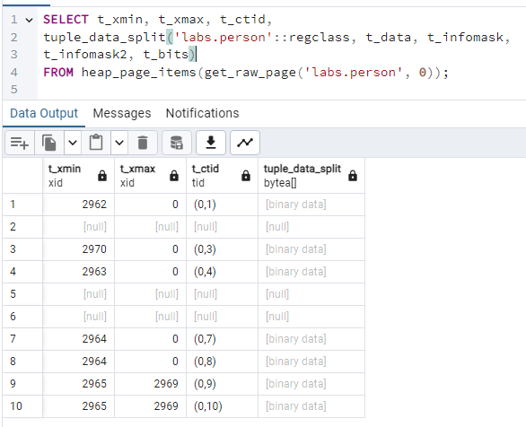

row 3 was filled.

After vacuum full:

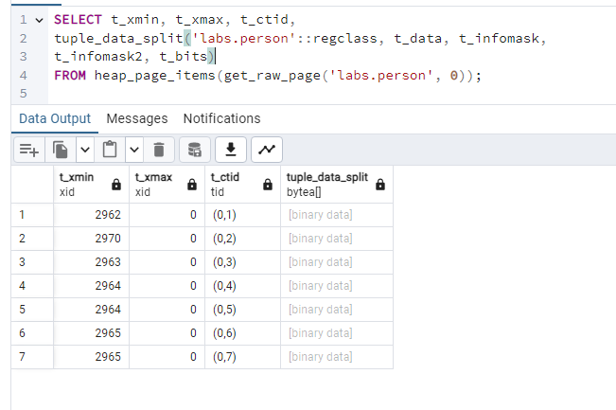It physically cleans the deleted rows rewriting the storage layout.

